1. Given a CustomerID, name and email, create a new Customer record

INSERT INTO Customer(CustomerID, Name, Email) VALUES (39, 'Jarred', 'jarr@mail.com');

A screenshot of a computer

Description generated with very high confidenceA screenshot of a computer

Description generated with very high confidence

1 ROW EFFECTED

SELECT * FROM CUSTOMER

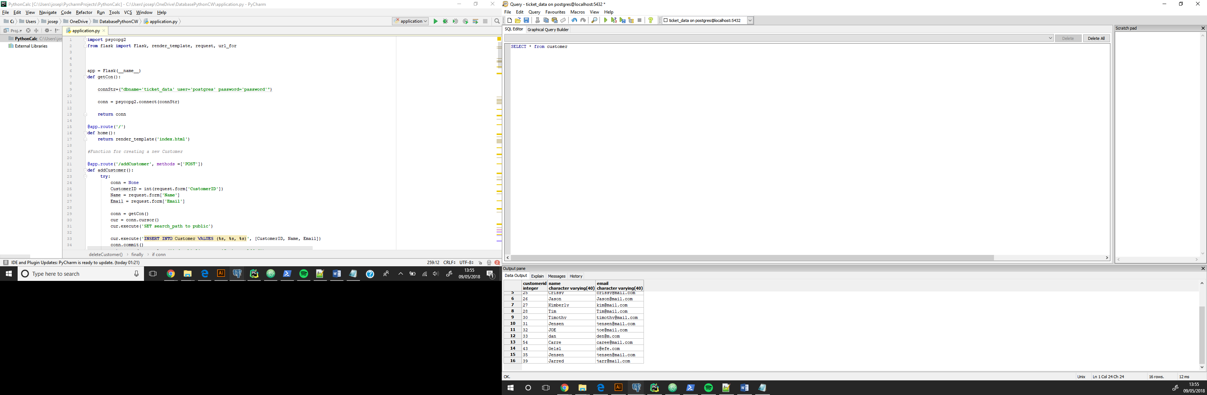

1. Create a new support ticket for a customer with respect to a given product. The application should display INSERT INTO TicketUpdate(TicketUpdateID, Message, UpdateTime, TicketID, StaffID) VALUES

(014, 'Your problem has been resolved', '2017-08-25 12 12:00', 14, 3045);

SELECT * FROM Ticket;

A screenshot of a computer

Description generated with very high confidenceA screenshot of a computer

Description generated with very high confidence

SELECT * FROM TICKET

A screenshot of a computer

Description generated with very high confidenceA screenshot of a computer

Description generated with very high confidence

1. INSERT INTO TicketUpdate(TicketUpdateID, Message, UpdateTime, TicketID, StaffID) VALUES

(014, 'Your problem has been resolved', '2017-08-25 12 12:00', 14, 3045)

1. SELECT distinct ticket.ticketid, ticket.status, ticket.loggedtime FROM ticket

RIGHT JOIN TicketUpdate ON Ticket.TicketID=TicketUpdate.TicketID

WHERE TICKET.status = 'Open'

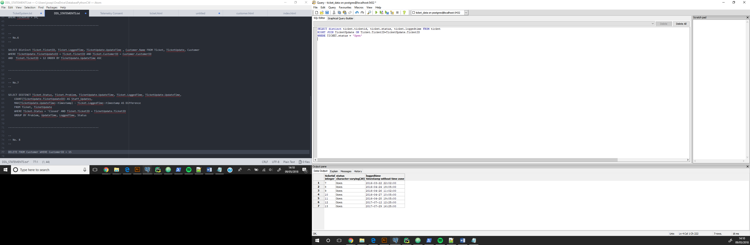

1. UPDATE Ticket SET Status = 'Closed' WHERE TicketID = 14;

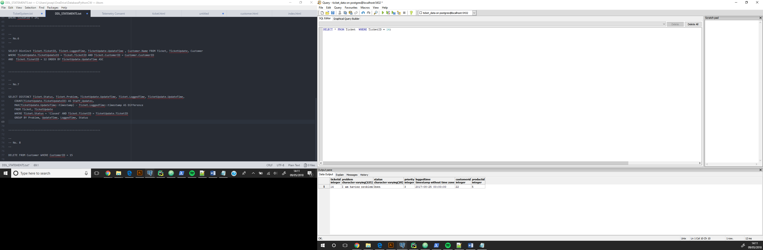Shows the ticket is still open

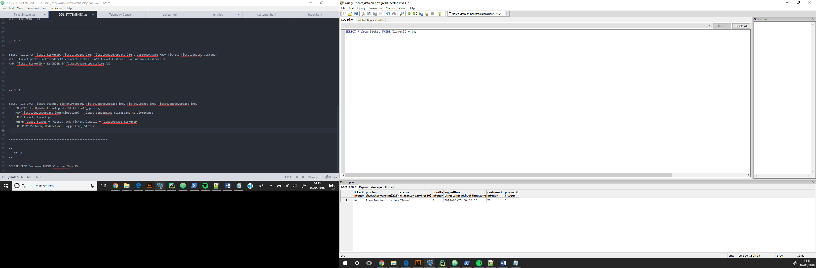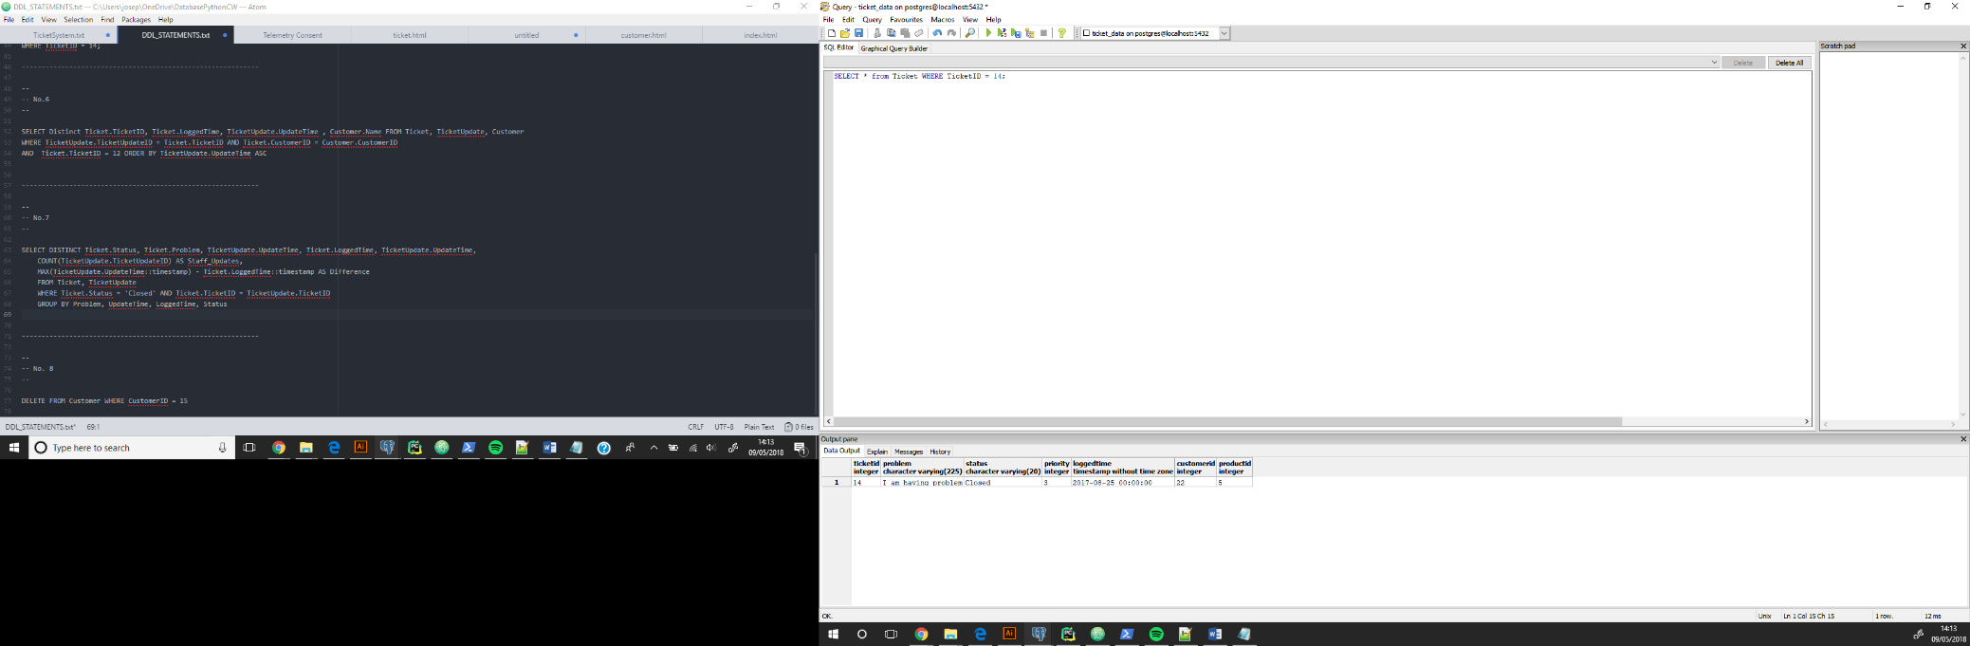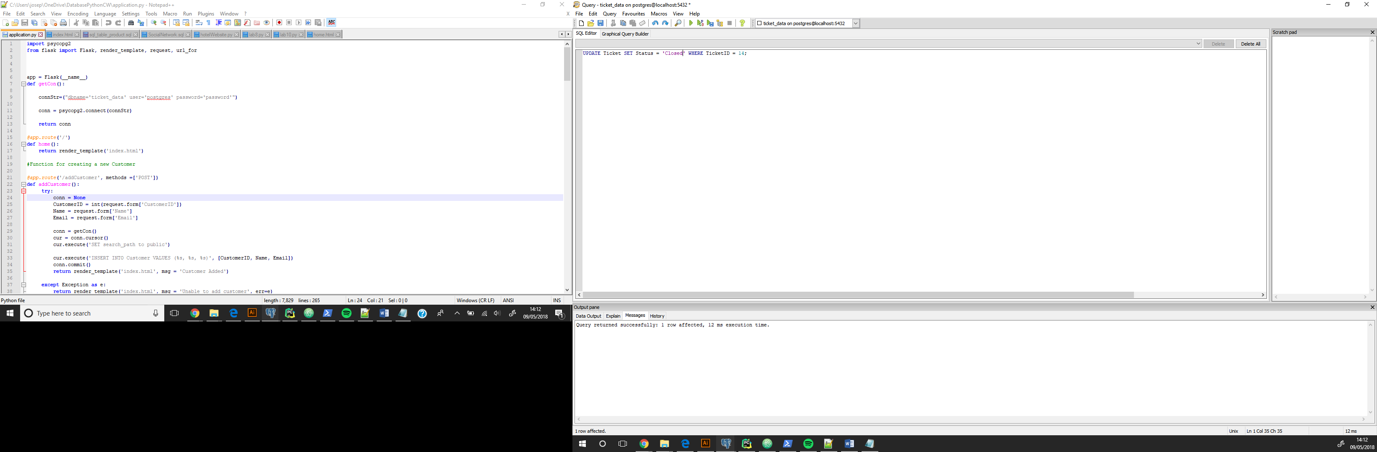

Shows that the ticket is now closed

1. SELECT Distinct Ticket.TicketID, Ticket.LoggedTime, TicketUpdate.UpdateTime , Customer.Name FROM Ticket, TicketUpdate, Customer

WHERE TicketUpdate.TicketUpdateID = Ticket.TicketID AND Ticket.CustomerID = Customer.CustomerID

AND Ticket.TicketID = 12 ORDER BY TicketUpdate.UpdateTime ASC

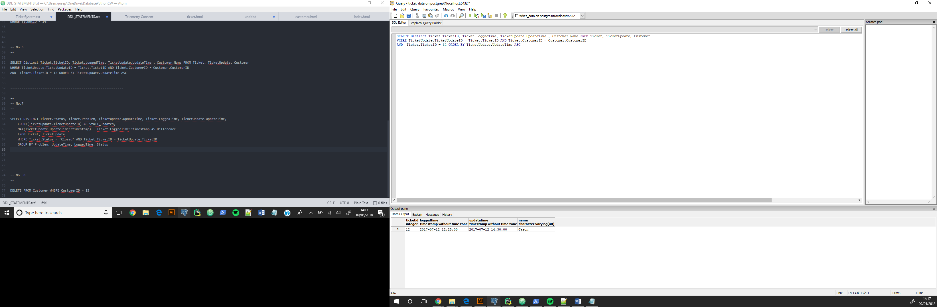

1. SELECT DISTINCT Ticket.Status, Ticket.Problem, TicketUpdate.UpdateTime, Ticket.LoggedTime,

TicketUpdate.UpdateTime,

COUNT(TicketUpdate.TicketUpdateID) AS Staff_Updates,

MAX(TicketUpdate.UpdateTime::timestamp) - Ticket.LoggedTime::timestamp AS Difference

FROM Ticket, TicketUpdate

WHERE Ticket.Status = 'Closed' AND Ticket.TicketID = TicketUpdate.TicketID

GROUP BY Problem, UpdateTime, LoggedTime, Status

A screenshot of a computer

Description generated with very high confidence

A screenshot of a computer

Description generated with very high confidence

1. DELETE FROM Customer WHERE CustomerID = 15

A screenshot of a computer

Description generated with very high confidence SELECT * FROM CUSTOMER WHERE ID = 15

AFTER SQL QUERY A screenshot of a computer

Description generated with very high confidence

